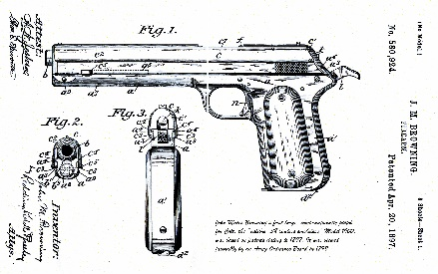
GANDALFRSO
.COM

Annual Reporting of Explosive Materials Storage Facilities to the Local Fire Authority
What Do You Need to Know?
  - Written comments must be postmarked and electronic comments must be submitted on or before November 21, 2023. Commenters should be aware that the electronic Federal Docket Management System will not accept comments after 11:59 p.m. Eastern Time on the last day of the comment period.
  - Note that comments will be posted within a few days of being submitted. However, if large volumes of comments are being processed simultaneously, your comment may not be viewable for up to several weeks. Please keep the comment tracking number that is provided after you have successfully uploaded your comment.
The Department of Justice is proposing to amend Bureau of Alcohol, Tobacco, Firearms, and Explosives (“ATF”) regulations to require that any person who stores explosive materials notify on an annual basis the authority having jurisdiction for fire safety in the locality in which the explosive materials are being stored of the type of explosives, magazine capacity, and location of each site where such materials are stored. In addition, the proposed rule requires any person who stores explosive materials to notify the authority having jurisdiction for fire safety in the locality in which the explosive materials were stored whenever storage is discontinued. These changes are intended to increase public safety.
The exact rule LINK

4710 Fishcreek Road, Stow, Ohio 44224
(330) 606-4583 mailto:dale@gandalfrso.com

